**Name:** T.Vamsi Kumar

**Batch:** June 01, 2022

**Tutor:** Raham Shaik

**Project: Integration of different tools with Jenkins & CICD automation thought another node docker container deployement appachey tomcat webserver and application.**

**Project:**

1. Created EC2 instance for Jenkins server and installed java git docker and jenkins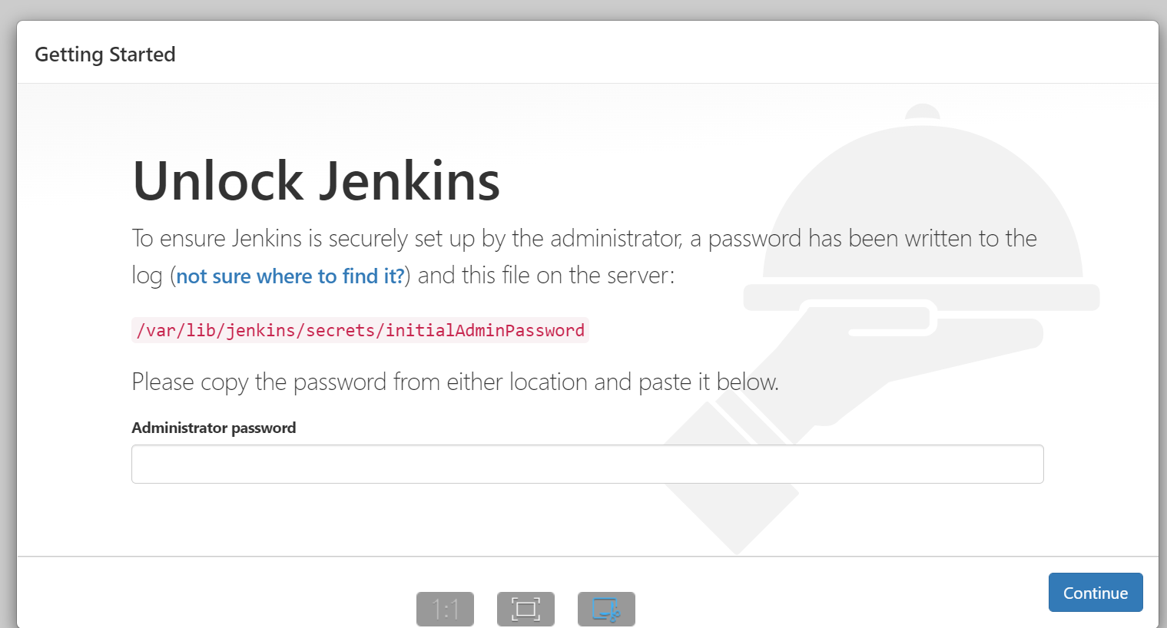
2. Created tomcat server and installed Java and tomcat server in that
3. Created EC2 instance and installed docker and Nexus
4. 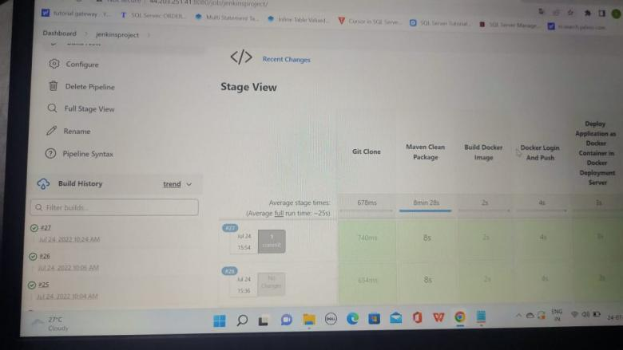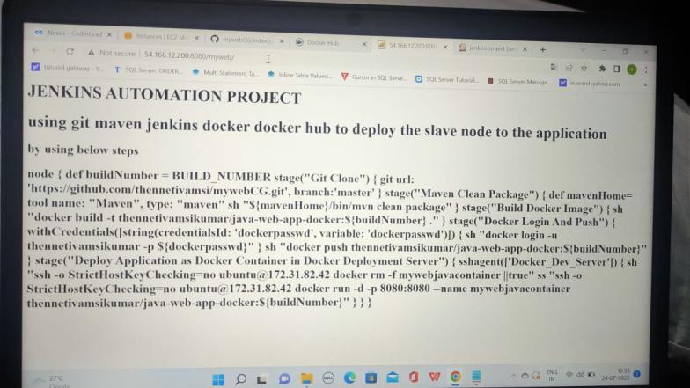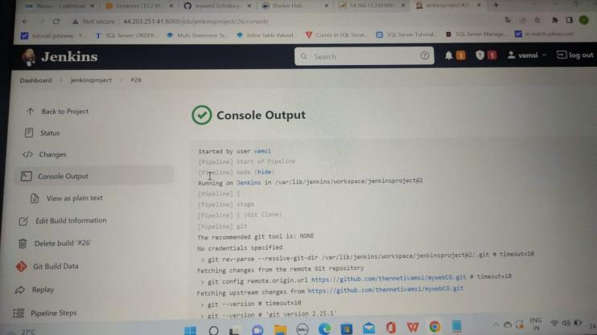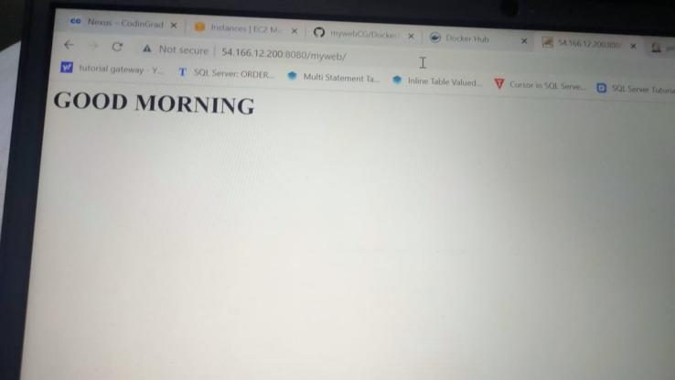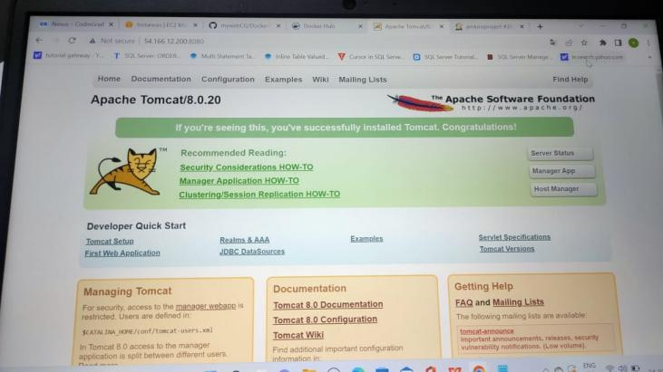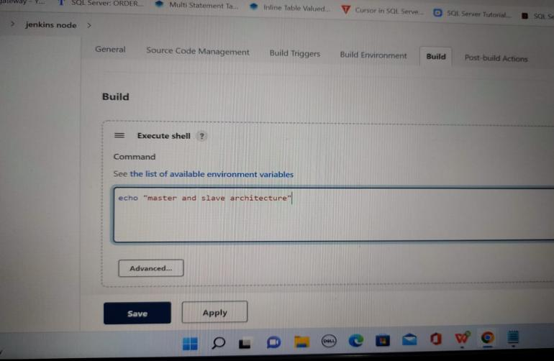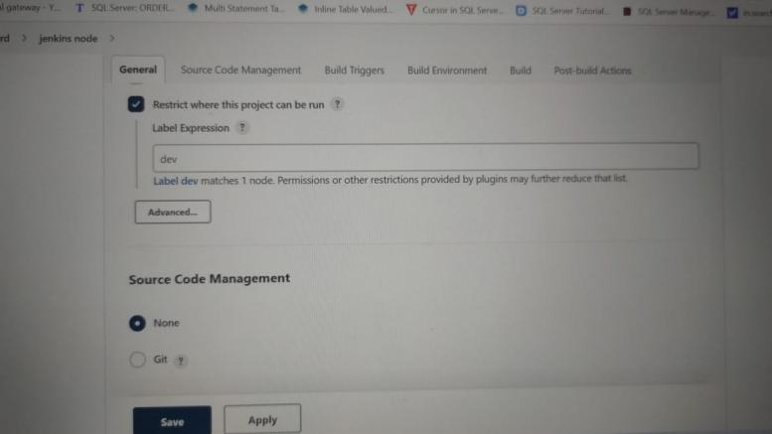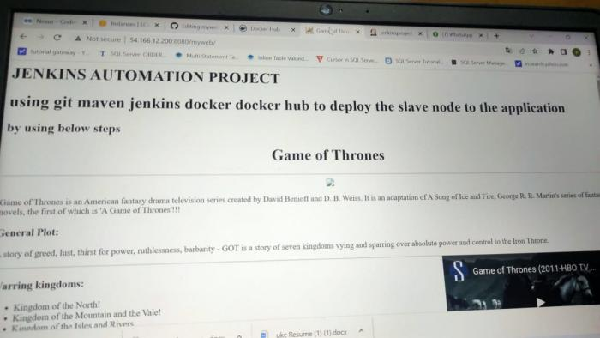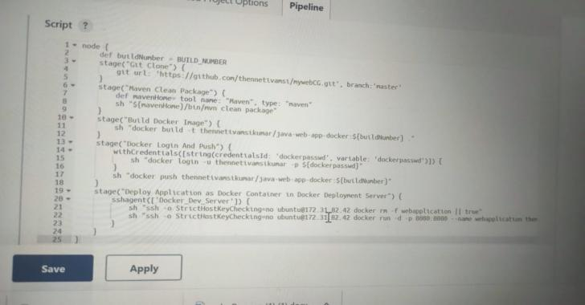
5. 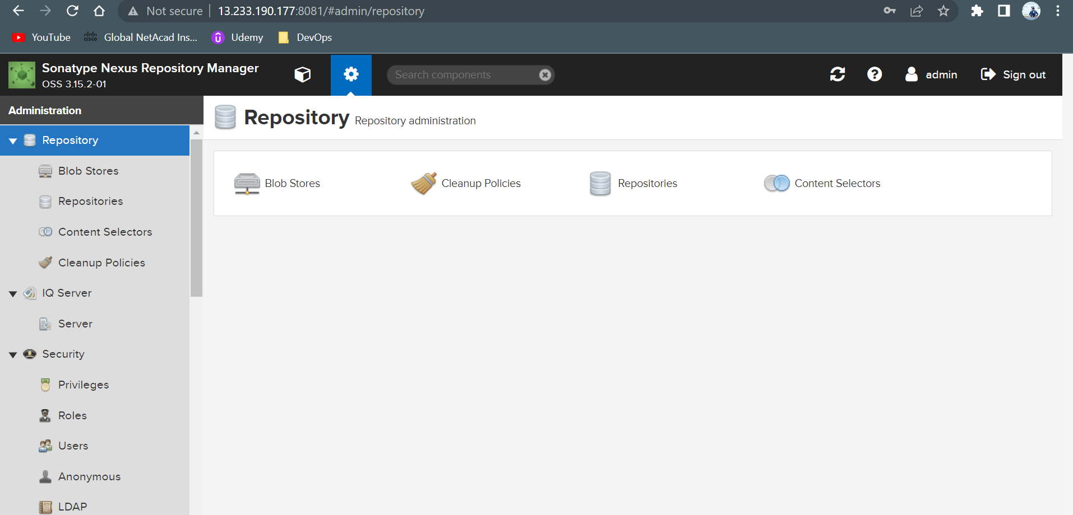
6. Logged into Jenkins page and created a new project
7. **Integrated** Github by adding repo url in source code management and Docker and dockerhub integrated with jenkins.
8. **Integrated** maven by installing maven in Jenkins by going to global tools cofnig and added maven version
9. In project configured maven and added maven goals like clean package sonar:sonar to create a package and code quality report in sonar qube.
10. Sonarqube details are configured in pom.xml of project and token was added for authentication
11. Nexus details configured in pom,xml and credentials configures in settings.xml under conf in maven clean deploy was applied in maven goals
12. Build the job and the job was success